- Prompt for amount, interest rate and no. of years and calculate simple interest.
SI.html
<html>
<head>
<title>Simple Interest Calculation</title>
</head>

<script type="text/javascript">
function simpl()
{
var p,r,t;
p=(prompt("Enter Principle"));
r=(prompt("Enter Rate"));
t=(prompt("Please Enter Time(year)"));
var si=(p*r*t)/100;
document.write("Simple Interest is: "+si);
}
</script>
<body>
<h1>SIMPLE INTREST</h1>
<input type="button" value="Calculate SI" onclick="simpl()"/>
</body>
</html>
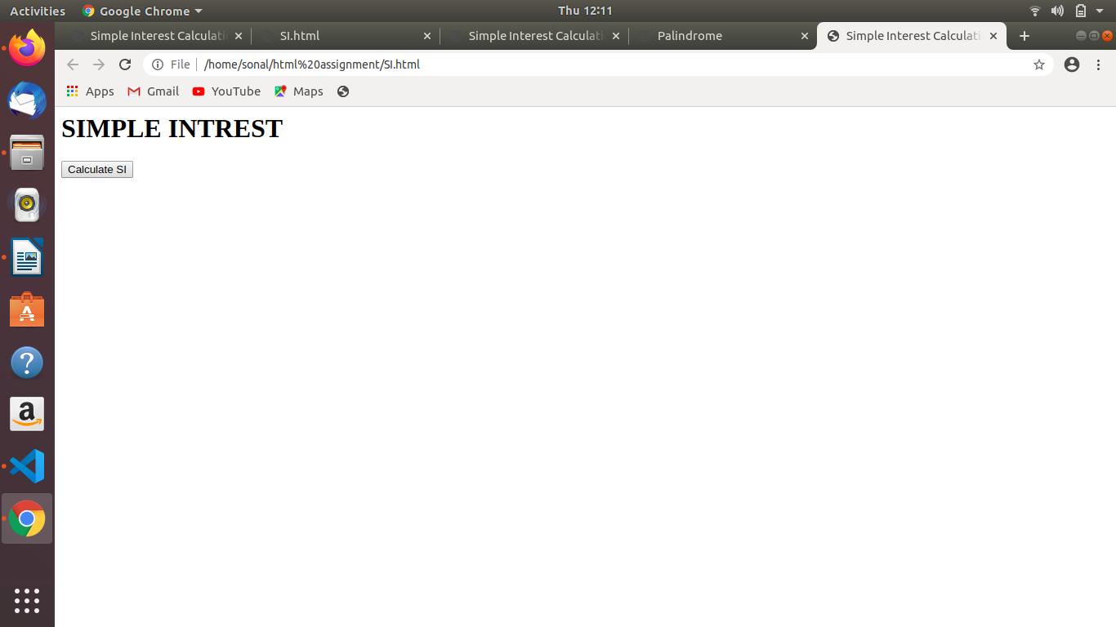
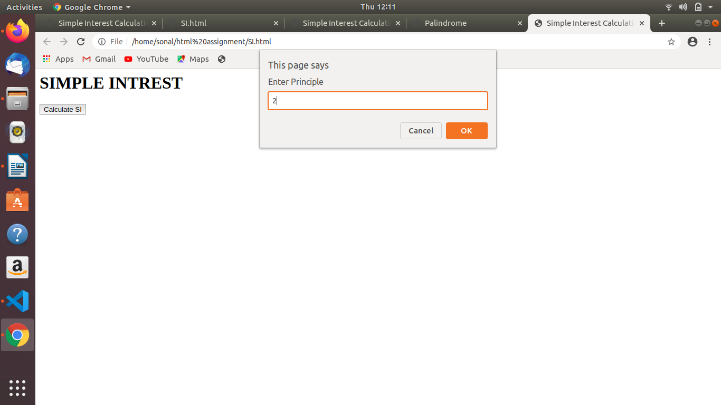
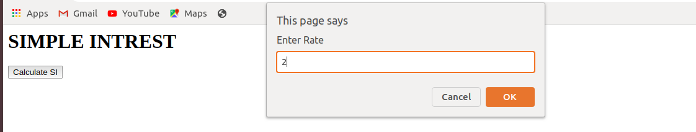
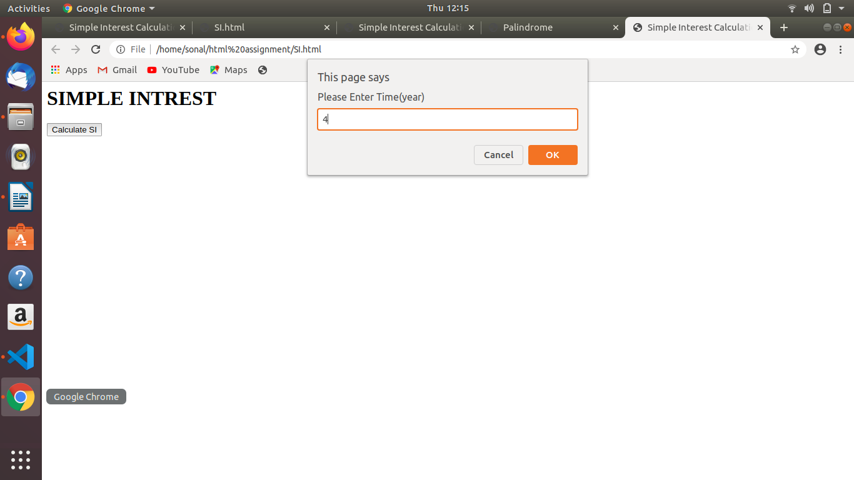
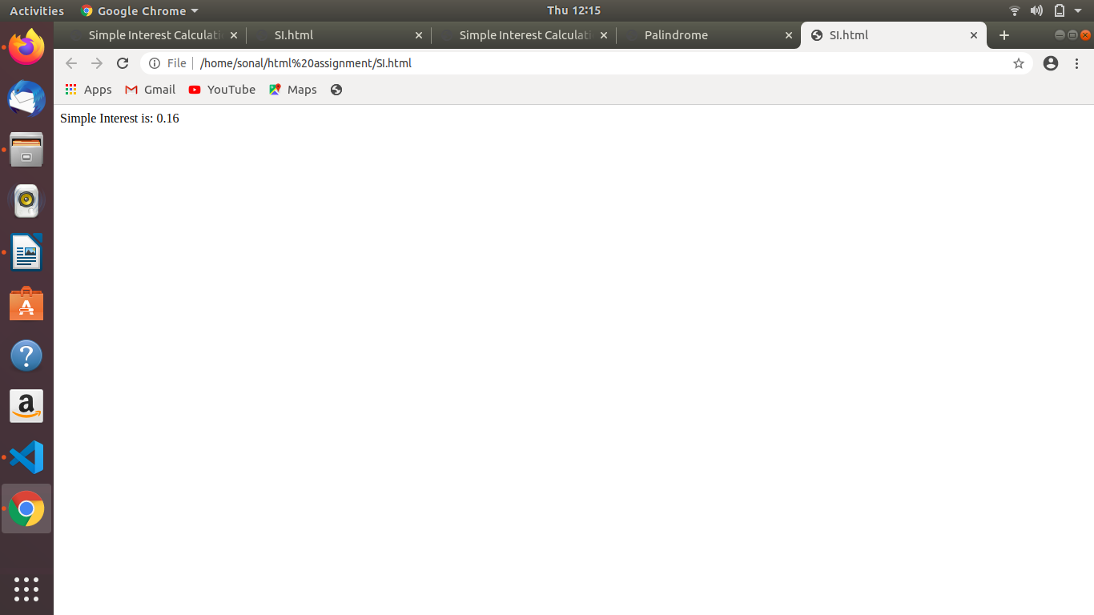

- is palindrome string
palindrome1.html
<html>
<head>
<title>Palindrome</title>
</head>
<body>
<script>
function palindrome(){
var str=prompt("enter string");
var str1=str.toLowerCase();
var rev=str1.split('').reverse().join('');
if(str==rev){
alert("palindrome");
}
else{
alert("not");
}
}
</script>
<input type="button" value="enter string" onclick="palindrome()">
</body>
</html>

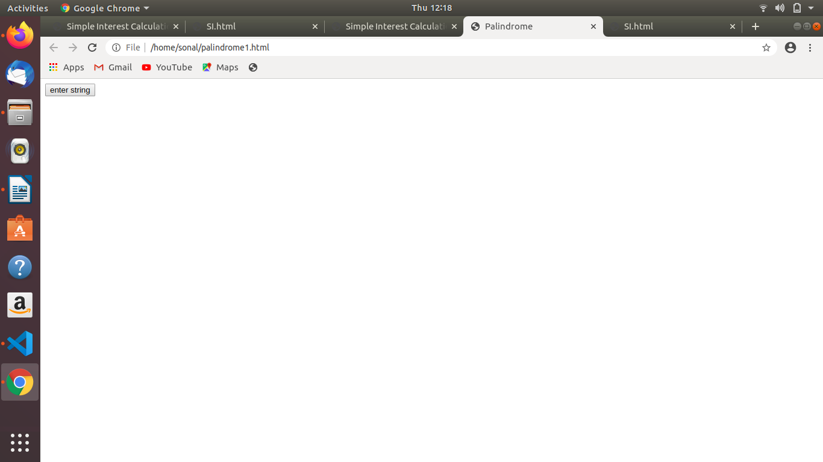
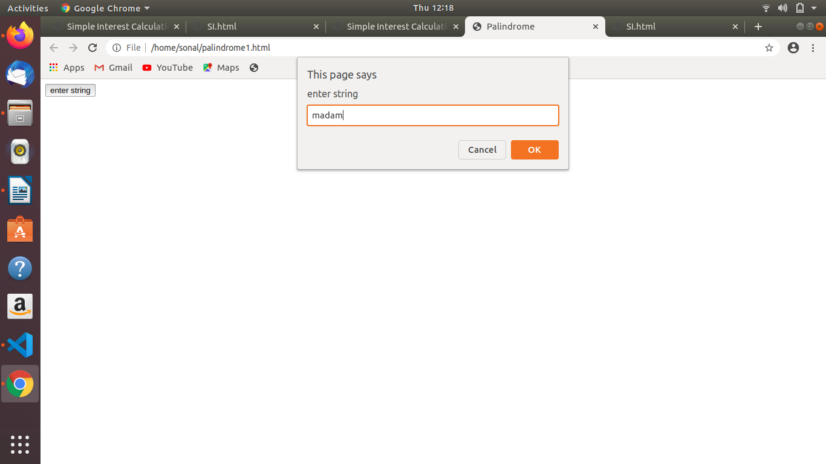
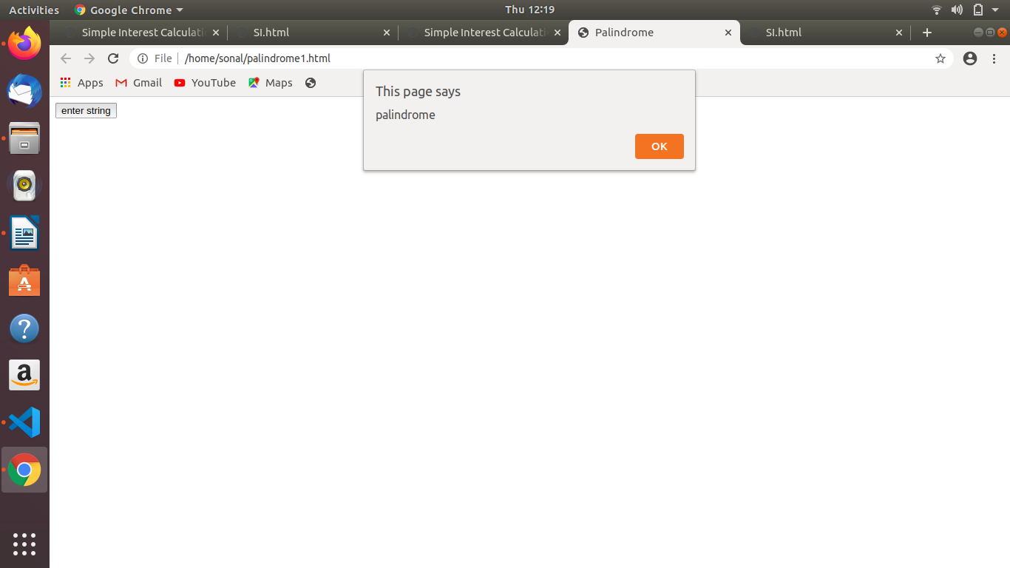

- Area of circle
area.html
<html>
<head>
<title>Area of a circle</title>
</head>
<body>
<script language="JavaScript">
function CalculateArea(){
var radius =document.form1.txtRadius.value;
document.write("<P>The area of the circle is " + (radius * radius * Math.PI) + "</p>");
}
</script>
<form name=form1>
Enter the radius of circle:
<input type="text" name="txtRadius" size=10>
<br>
<input type="button" value="Result" onClick='CalculateArea();'>
</form>
</script>
</body>
</html>

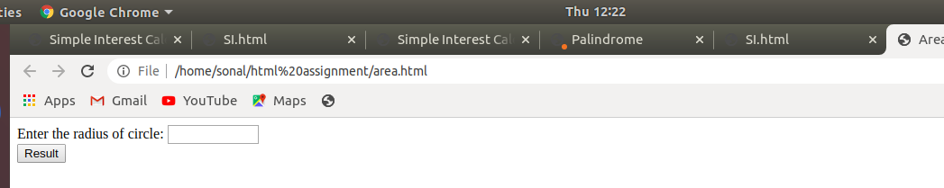
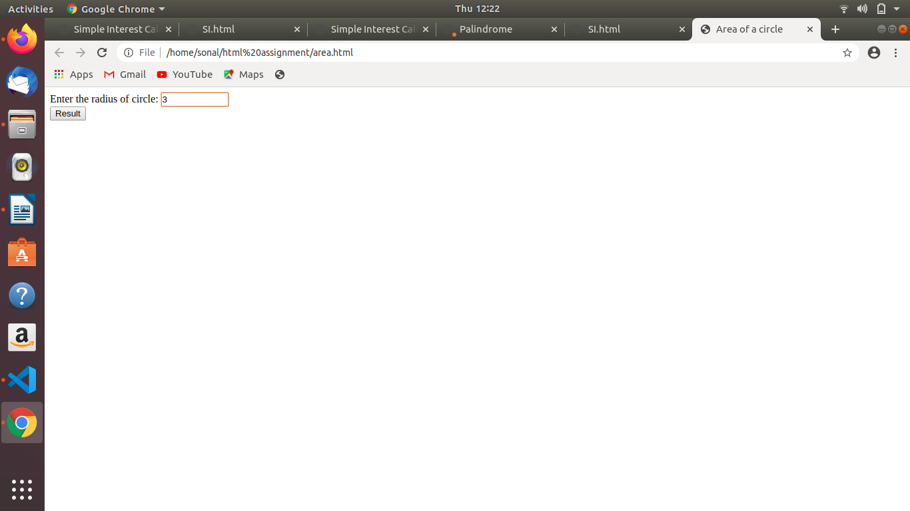
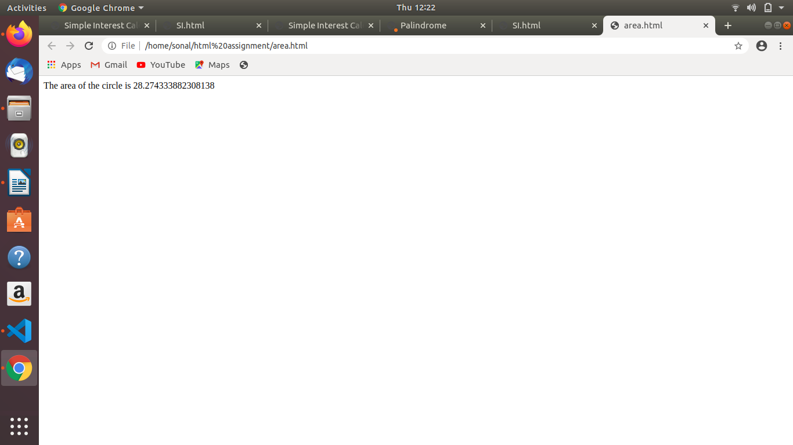

- Copy information of one object to another and log it to console.
Copy.html

<html>
<head>
<title>COPY</title>
</head>
<body>
<p id="demo"></p>
<p id=""></p>
<script>
var obj1 = {
name:"sonal",
age:"20"

}
var obj2=Object.assign({},obj1);
console.log(obj2);

</script>
</body>
</html>

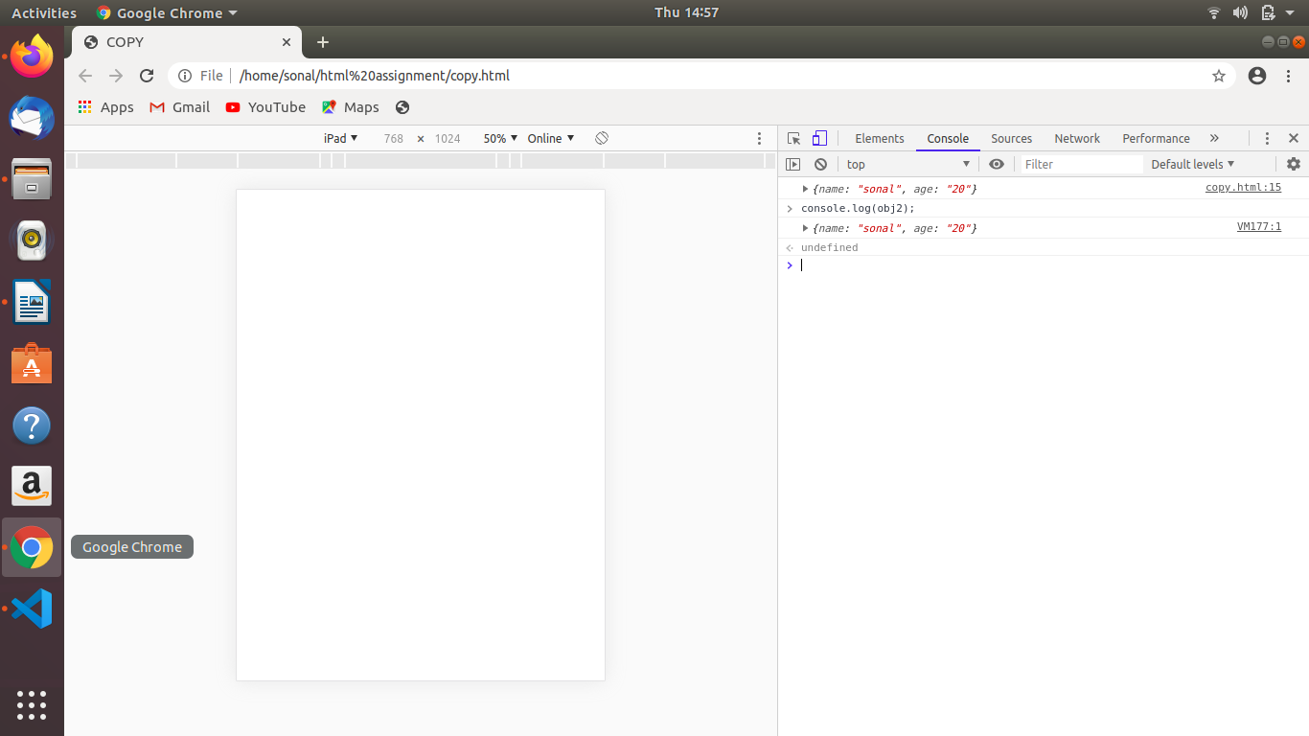

- create a list of objects of Employee with info as follow :
  - Name, age, salary ,DOB
  - filter all employees with salary greater than 5000
  - group employee on the basis of their age
  - fetch employees with salary less than 1000 and age greater than 20. Then give them an increment 5 times their salary.

list.html

<!DOCTYPE html>
<html>
<head>

<title>Employee Data</title>
<script >
var Employee = [
{ Name: 'Sonal', age: 22, salary: 500 ,DOB:'15/01/1996'},
{ Name: 'Neha', age: 18, salary: 10000 ,DOB:'02/02/1999'},
{ Name: 'Abhishek', age: 37, salary: 5000 ,DOB:'25/07/1980'},
{ Name: 'Vijay', age: 40, salary: 15000 ,DOB:'16/03/1980'},
];
document.write( "<b>Employee's Details:<br> </b>");
for(var i in Employee)
{
document.write("Name: "+Employee[i].Name +" Age:"+ Employee[i].age + " Salary:" + Employee[i].salary + " DOB:" + Employee[i].DOB + "<br>");
}

document.write( "<br> <b>Employees with salary greater than 5000 : </b><br>");
for(var i in Employee)
{
if(Employee[i].salary>=5000)
document.write(" "+Employee[i].Name+"<br>");
}

document.write("<br><b>Employees on the basis of their age:</b>");
var agelessthan20=[];
var age21_30=[];
var age30above=[];
for(var i in Employee){
if(Employee[i].age<=20)
agelessthan20.push(Employee[i].Name);
else if(Employee[i].age<=30)
age21_30.push(Employee[i].Name);
else
age30above.push(Employee[i].Name);
}
document.write("<br>age less than 20: "+agelessthan20);
document.write("<br>age between 20 and 30: "+age21_30);
document.write("<br>age above 30: "+age30above+"<br>");

document.write("<br><b>employees with salary less than 1000 and age greater than 20 and then give them increment 5 times their salary.</b>");
var salaryhike=[];
for(var i in Employee){
if(Employee[i].salary<=1000&&Employee[i].age>20)
{
document.write("<br>");
var old=Employee[i].salary;
Employee[i].salary=Employee[i].salary*5;
document.write("name: "+Employee[i].Name+" old salary: "+old+" new salary: "+Employee[i].salary);
}
}

</script>
</head>
</html>

